Captured data preprocessing
In the workflow provided by Wuhan University, the data collected need to be preprocessed before being fed into the subsequent process.
The workflow of data preprocessing is shown in Fig. It contains three stages: frame extraction, IMU conversion and frame match. The result of the preprocessing is that the data collected by different software will be sampled to a frequency of 1 Hz and provide an unlabeled dataset with geopose data in the TrainingDML-AI format.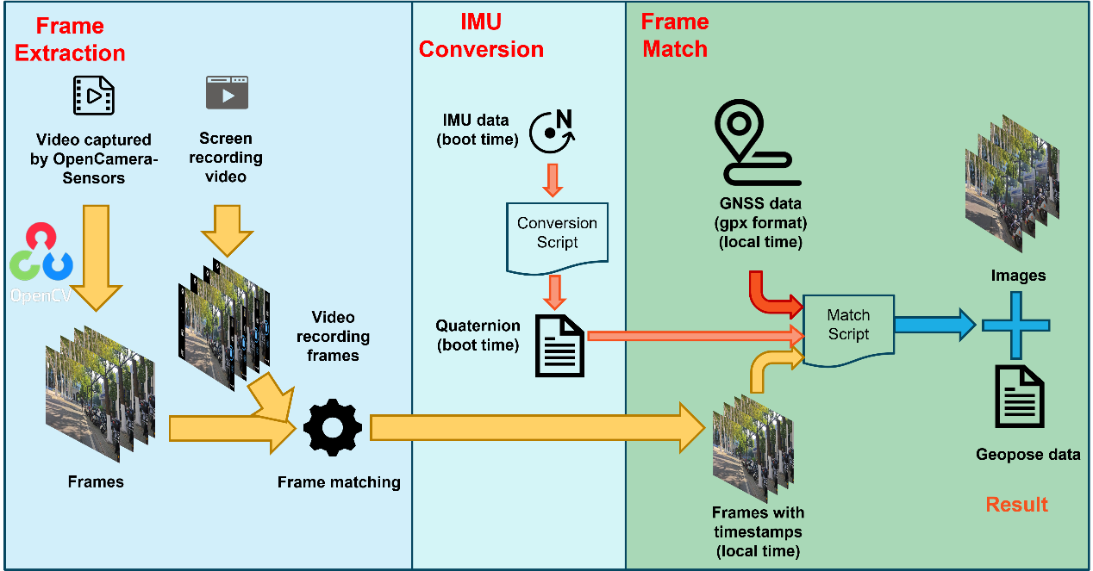

Frame Extraction
Video captured by OpenCameraSensors (main video) has no timestamps. To solve this problem, screen recording video (support video) is saved to calculate the timestamp for them. Specifically, firstly, videos would be cut into frames (main frames and support frames) using OpenCV. Then the same frame could be found manually. The timestamp on the support frame could be referred as the timestamp for same frame in main frames. Since the main video are collected in 30Hz, precise timestamps could be calculated for main frames. It should be noted that the timestamp in this stage is the local time. Main frames with timestamp could be used in subsequent processes.

IMU Conversion
The purpose of IMU conversion is to convert the collected IMU data into geopose. The IMU data collected by the OpenCameraSensors includes the accelerometer data, gyroscope data, and magnetometer data, each with a timestamp. Note that the three data don’t have the same frequency and start time, so they should be pre-processed using algorithms such as the Kalman filter, converted to 30Hz geopose data for subsequent processing. As it is not the main research focus of this pilot, the algorithm for converting IMU data to geopose will not be elaborated here. The converted data is encoded in xml format, using x, y, z, w to represent the pose of the camera, each pose records a timestamp of the boot time since the mobile phone was booted.

Frame Match
This stage aims to match frames, and prepare ready-to-label dataset. The result of this stage is images with geopose data. The manual work required at this stage is to calculate the difference between the boot time and the local time. This can be done by the frames, which has boot timestamp, provided by the app. Then the time in IMU data according to this interpolated value. The next step is to sample all the data to a frequency of 1Hz. To simplify the process, the frames and geopose data closest to the sampling time of the GNSS data are selected. Therefore, the output data has a frequency of 1Hz, which is the same as the lowest of all the data sampled, i.e., the GNSS data. The GNSS data collector can be changed if the sampling frequency needs to be increased to obtain higher accuracy data.
The result of preprocessing will be provided as an unlabeled dataset in TrainingDML-AI format. Frames will be organized into frame sequences. Metadata including identification, name, amount and geopose data will be recorded in JSON format, and because of the extensibility of TDML, labels can be extended into it after the annotation.

